Data Visualisation

1. Total World Emission

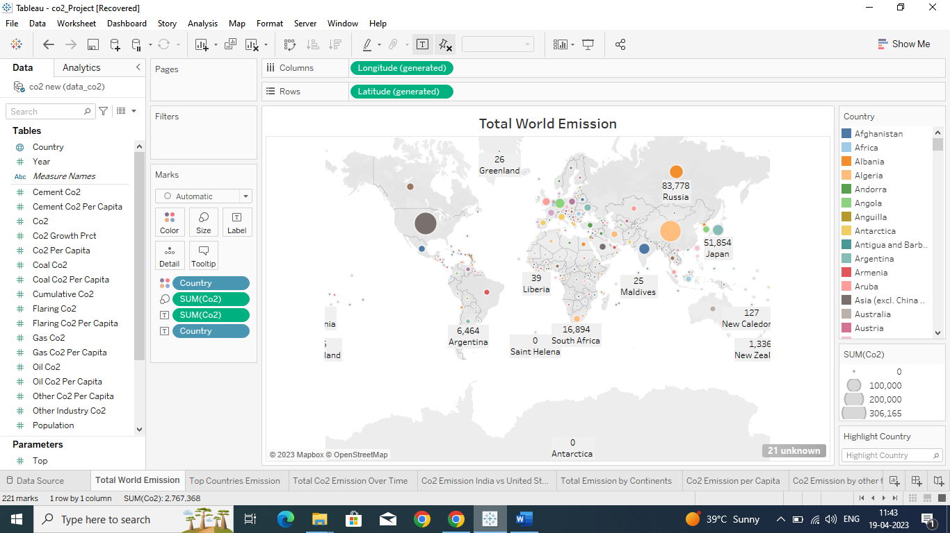

1. Top Emitting Countries

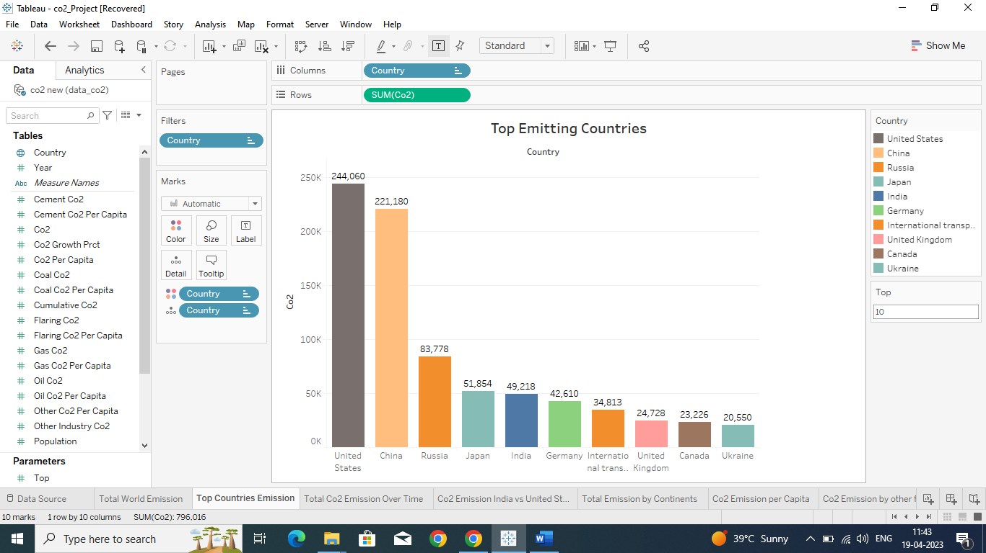

1. Total Co2 Emission Over Time

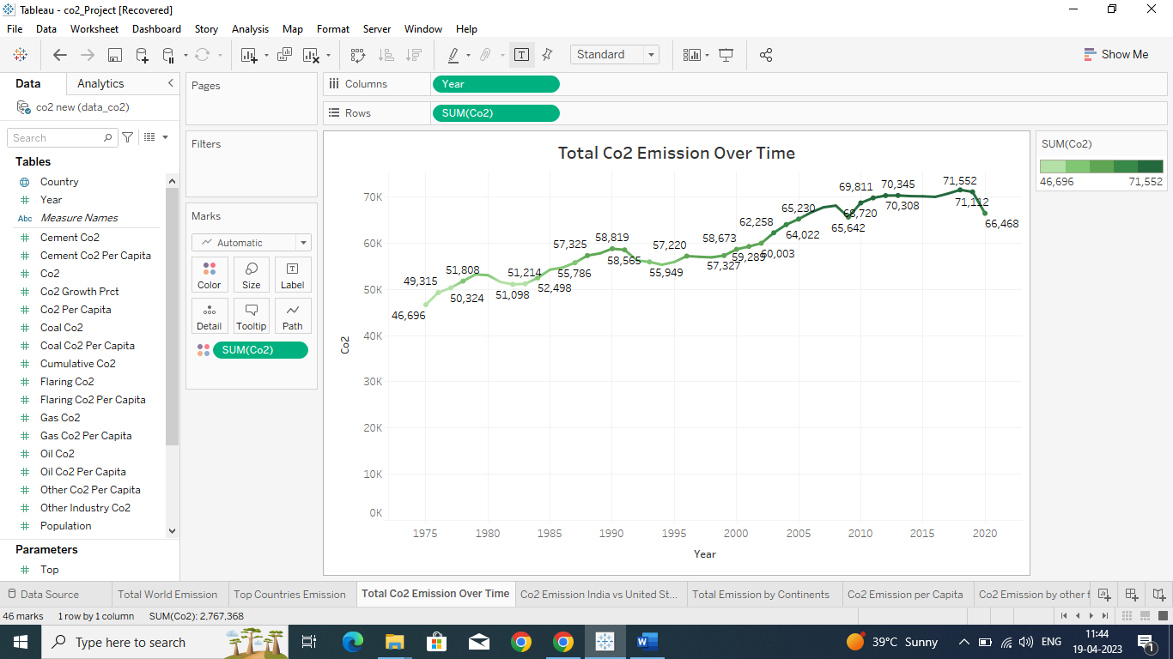

1. Co2 Emission India vs United States

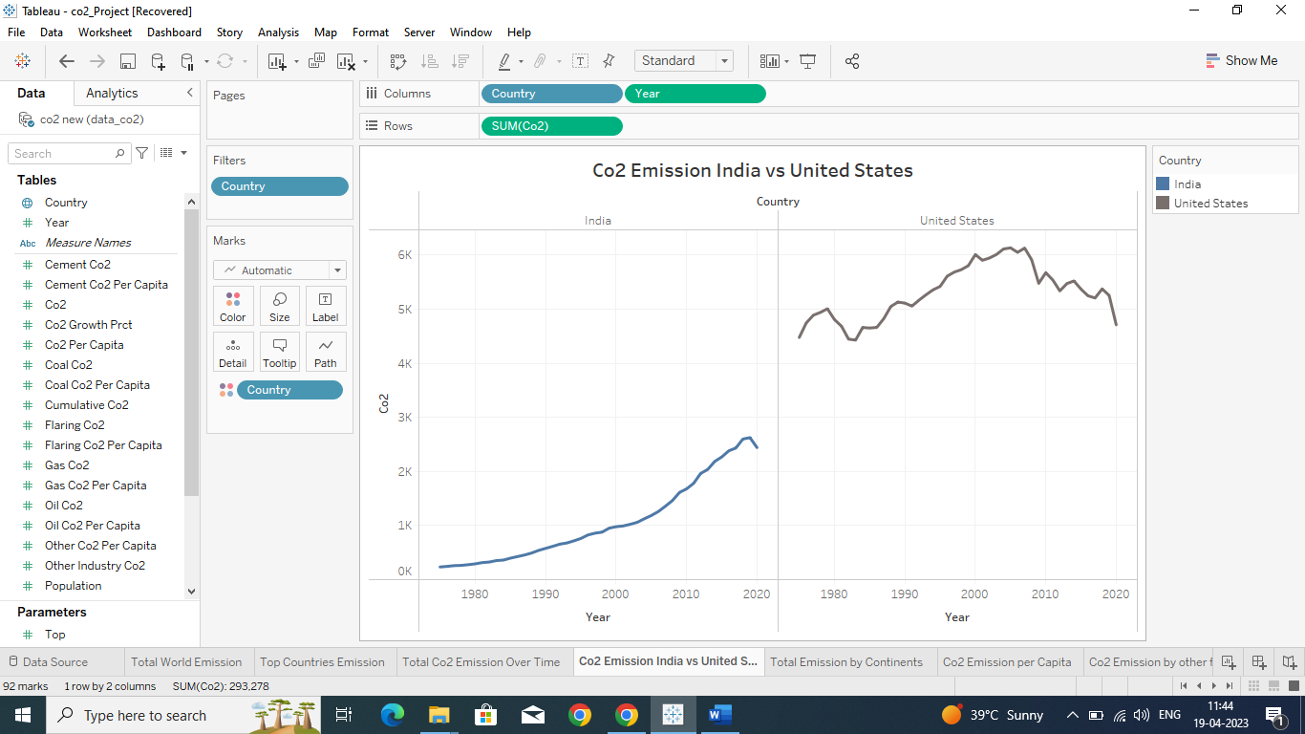

1. Total Emission by Continents

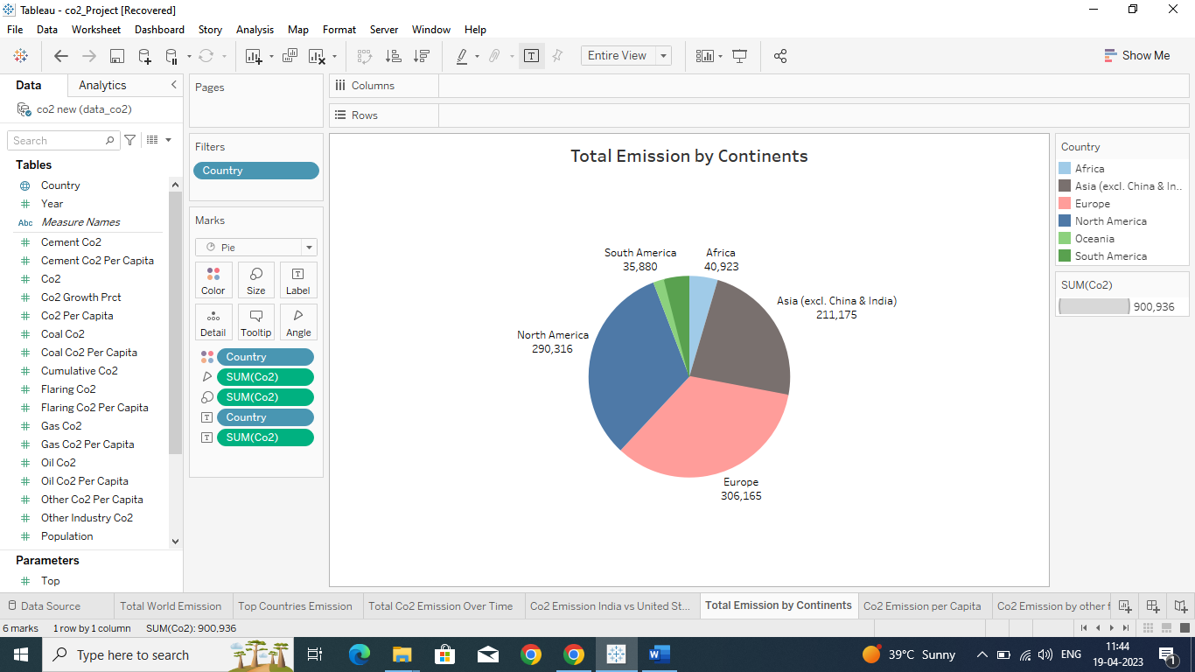

1. Co2 Emission Per Capita

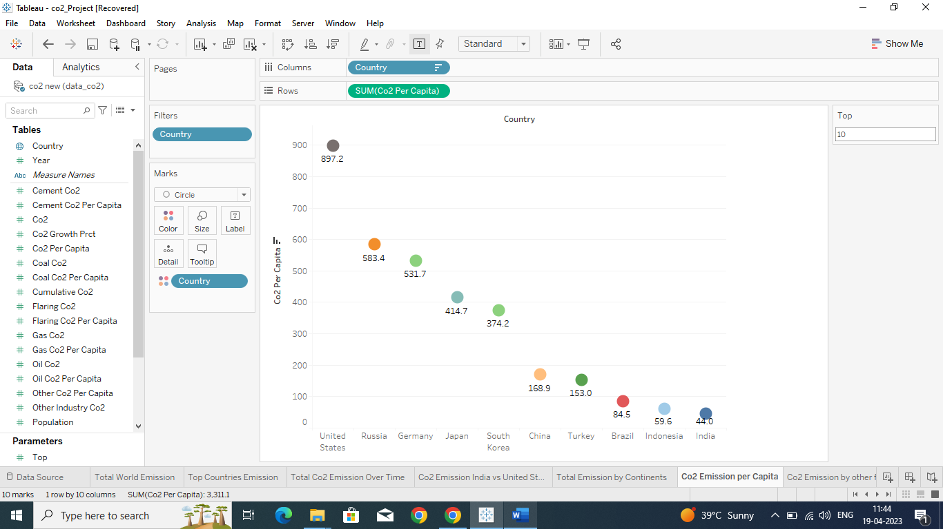

1. Co2 Emission by Other Factors

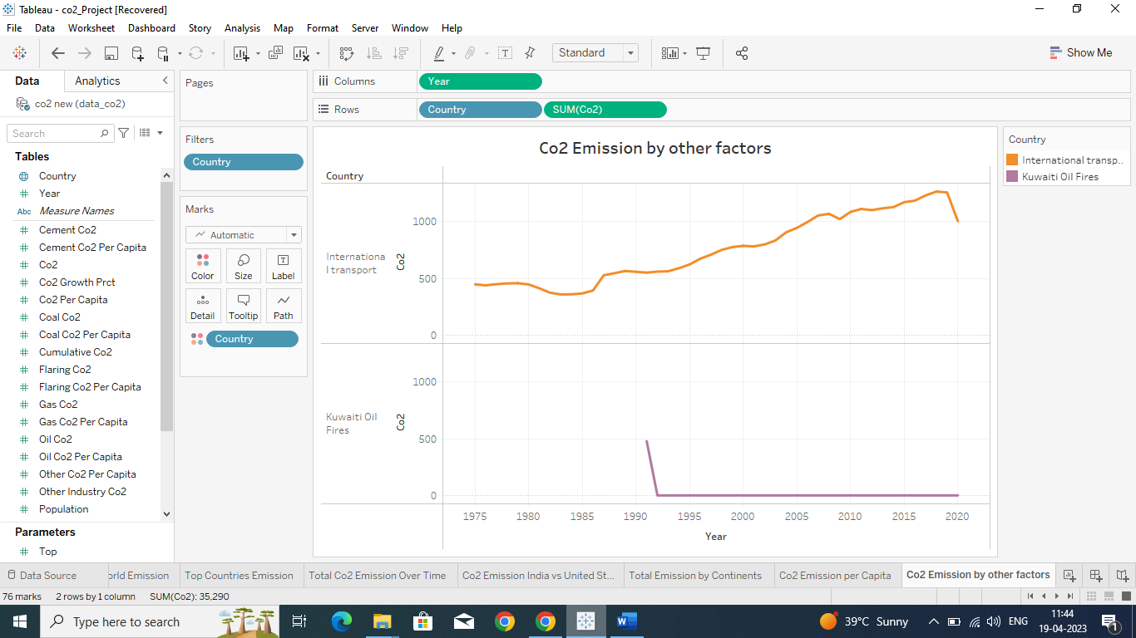

1. Emission Rate by Internal Factors

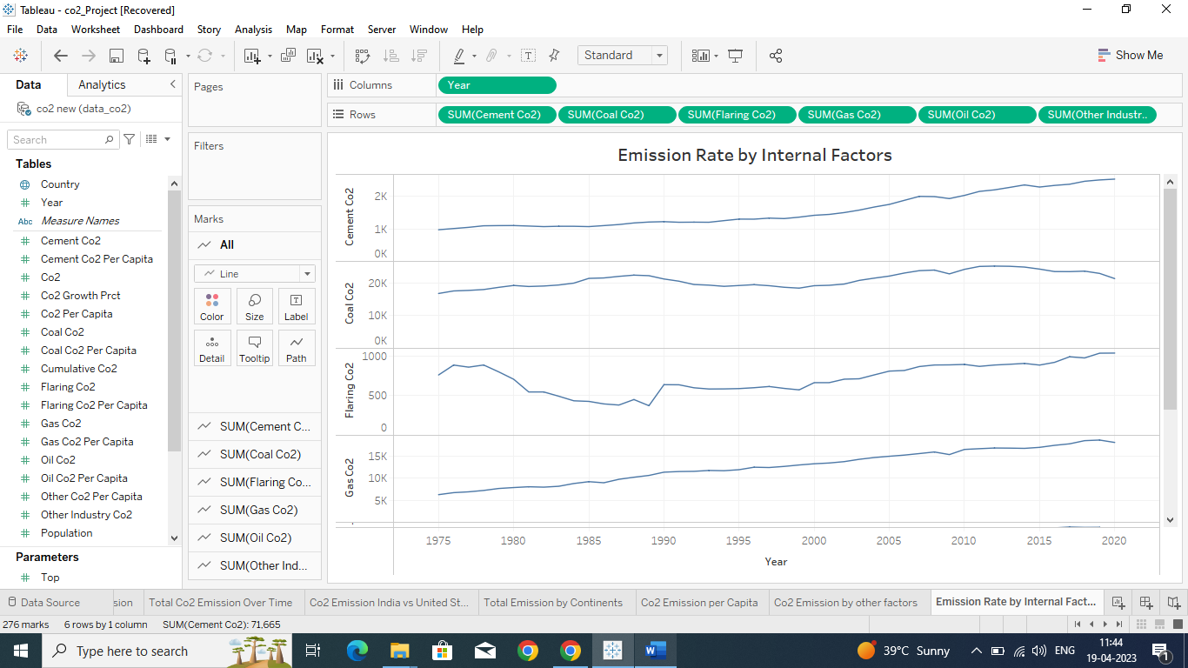

1. Donut Chart for Coal Co2

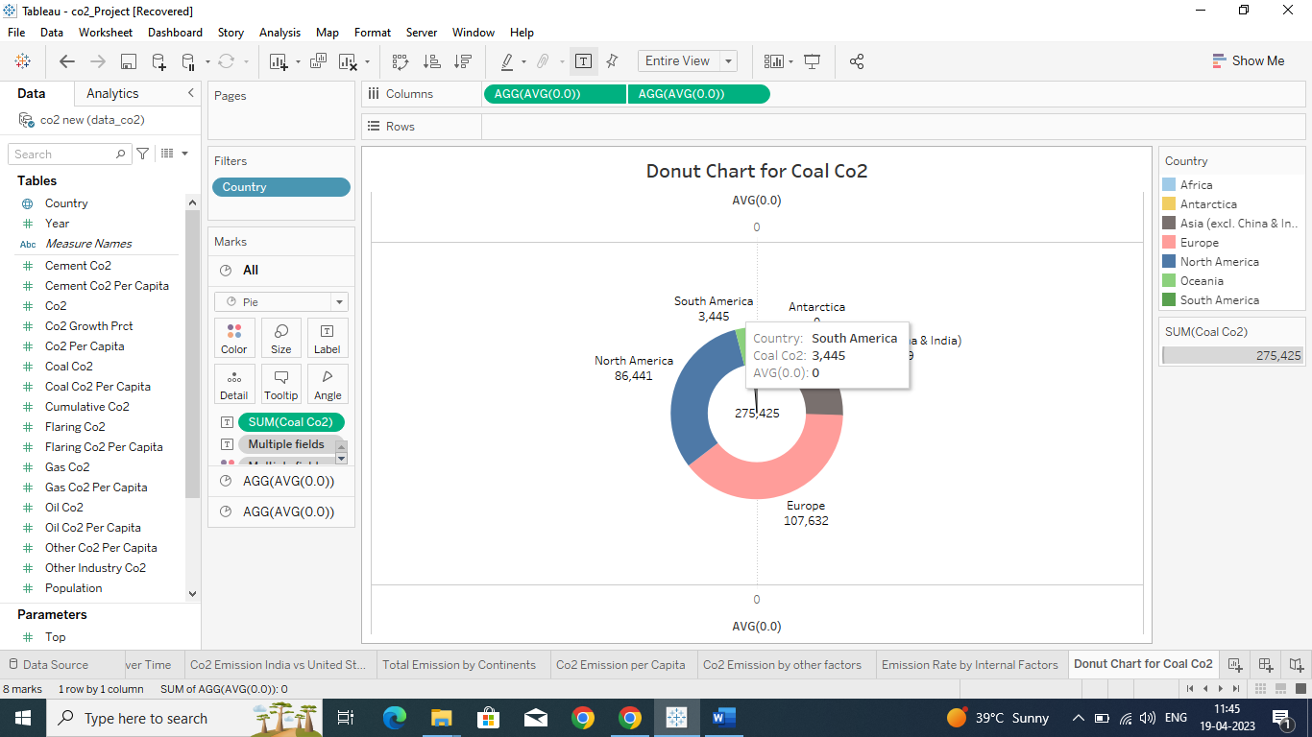

1. Donut Chart for Cement Co2

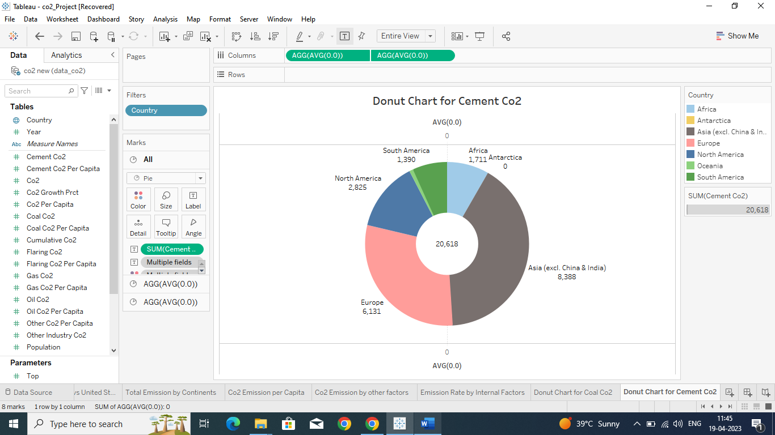

1. Donut Chart for Flaring Co2

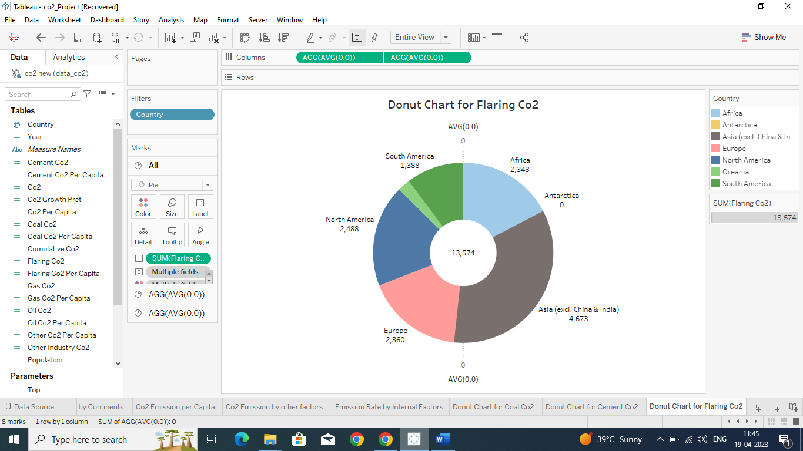

1. Donut Chart for Gas Co2

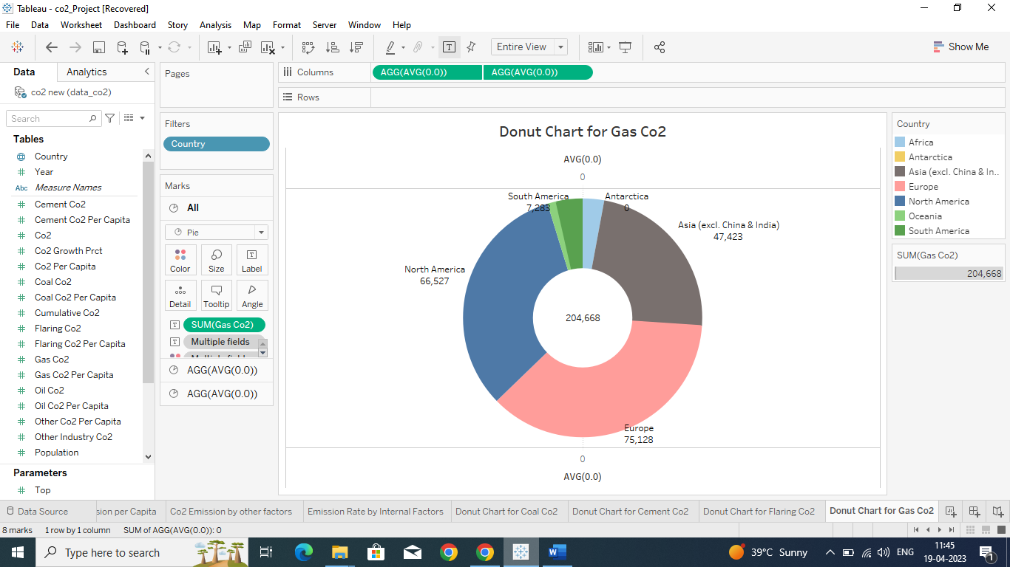

1. Donut Chart for Oil Co2

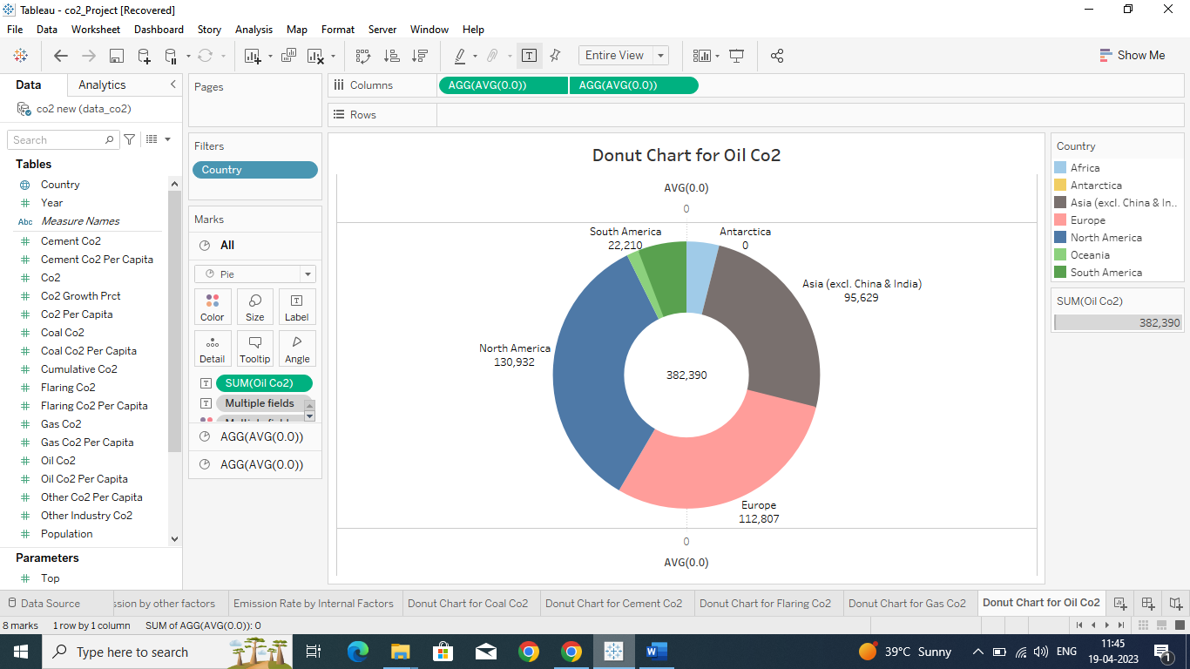

1. Donut Chart for Other Industry Co2

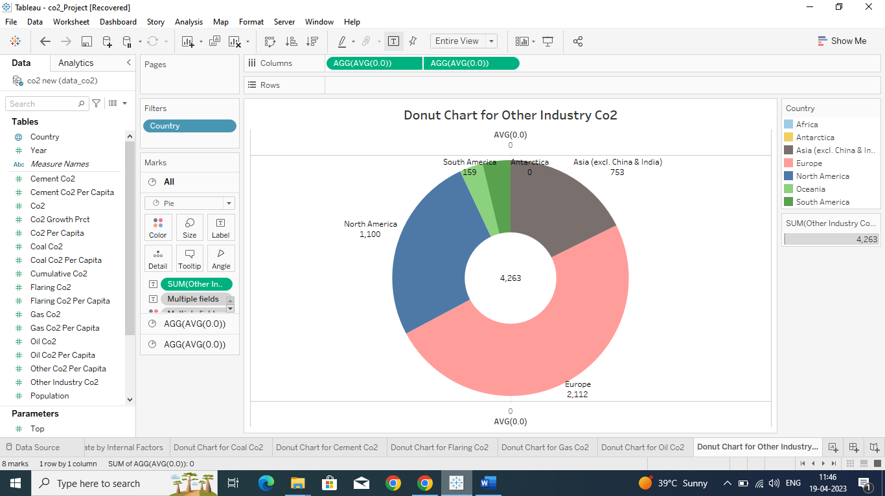

1. Co2 Emission for Past 10 Years

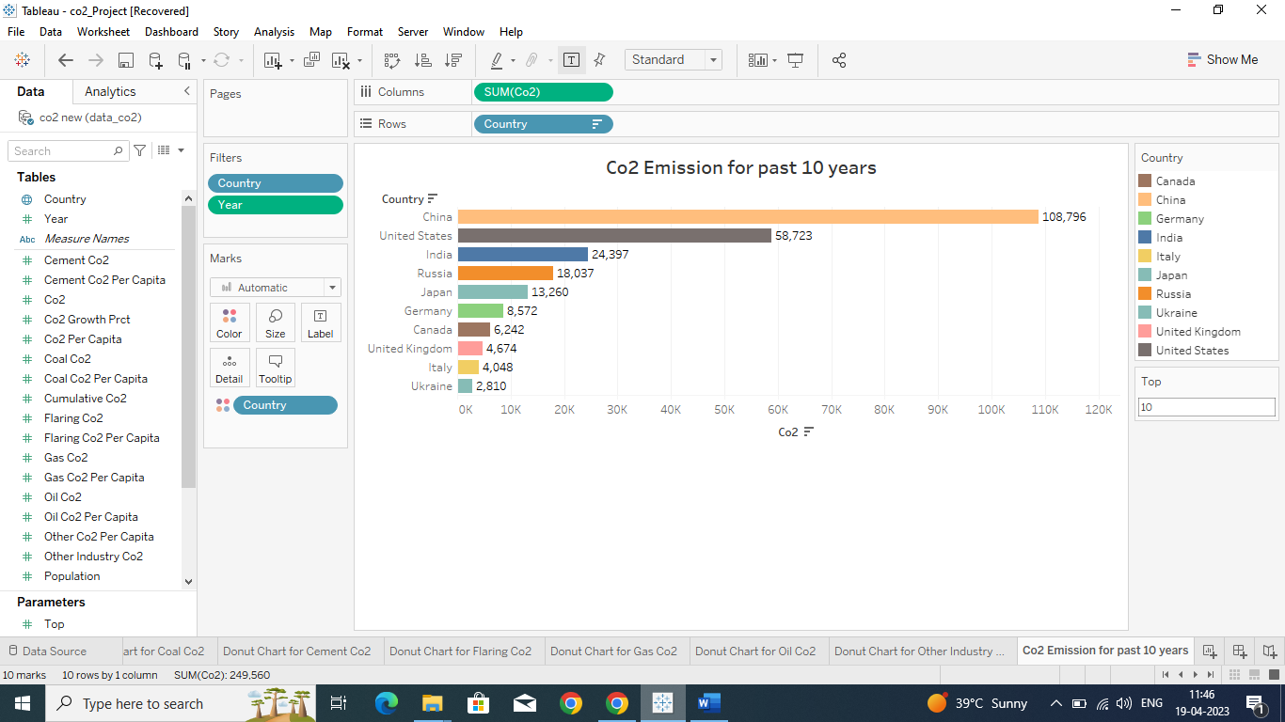

1. Overall Contribution by India in Co2 Emission

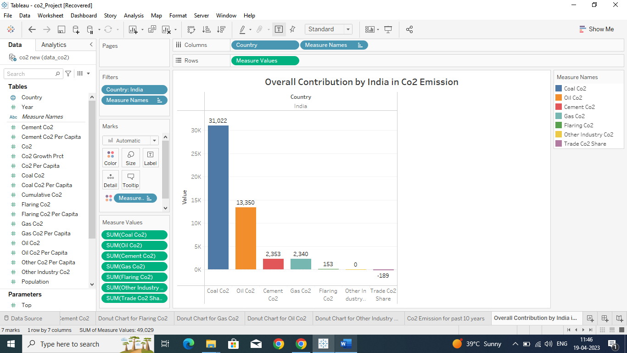

1. Continent Wise Contribution by Internal Factors

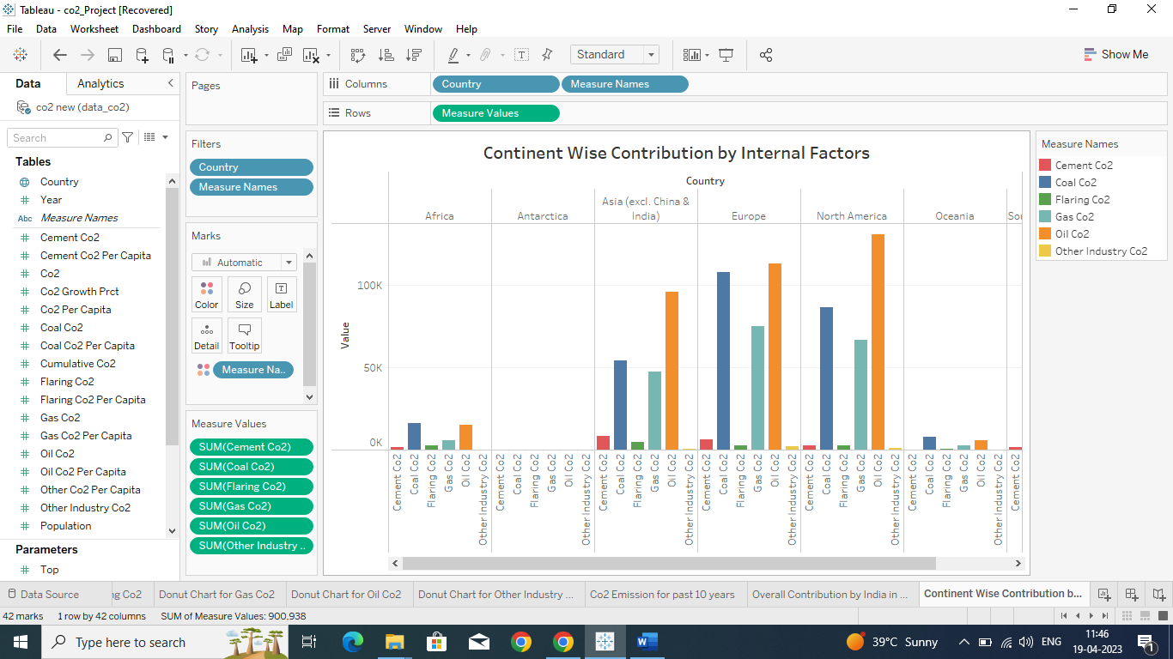

1. Co2 Emission from 1990 to 2020 0n Internal Factors

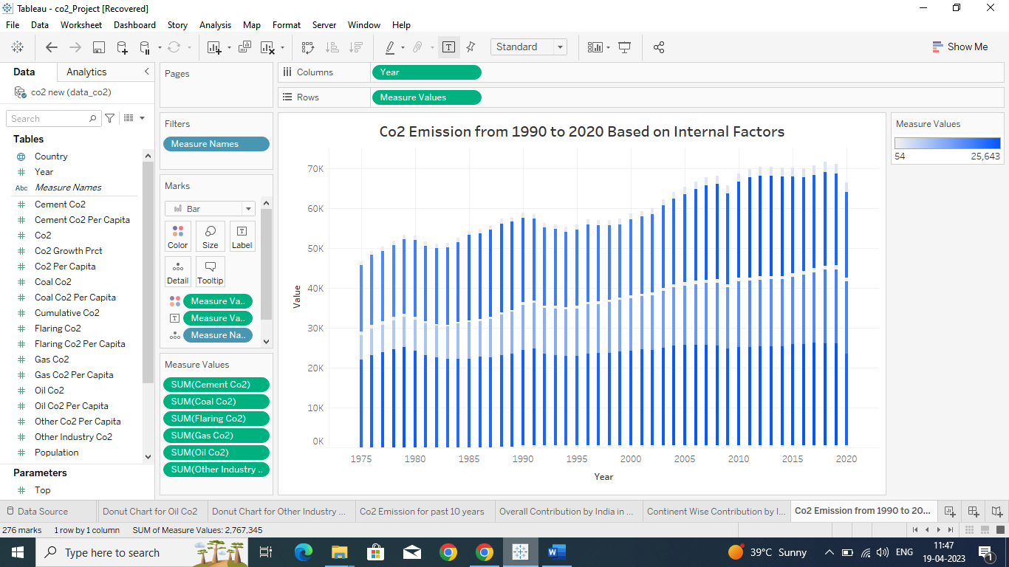

1. Cumlative co2 and per Capita Over Years

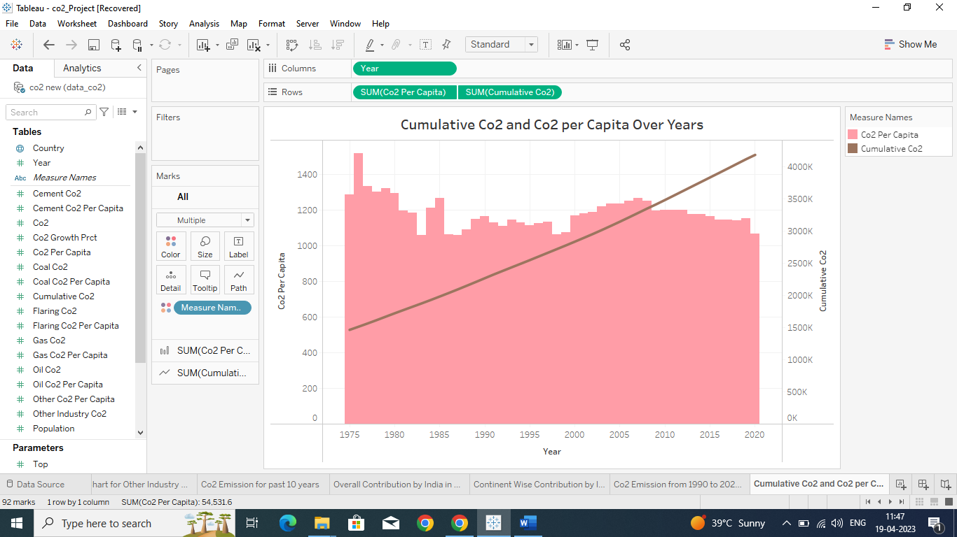

1. Co2 Emission in 2020

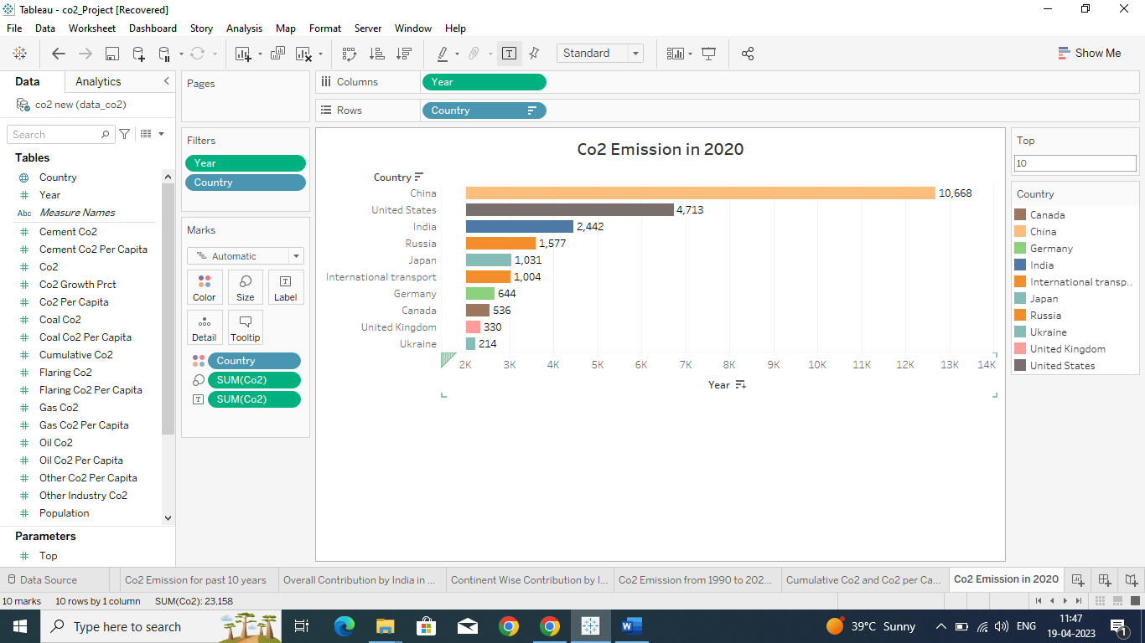

1. China vs India Internal Factor

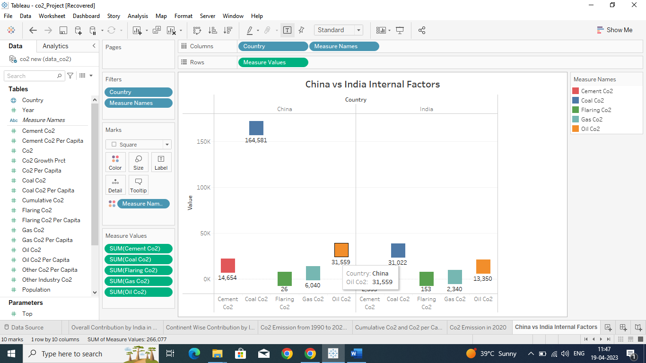

1. Overall Contribution by China in Co2 Emission

